A Collaborative Requirement Elicitation Technique for SaaS Applications
Xin Zhou¹, Li Yi2, Wei Zhang2, Haiyan Zhao2
1 IBM Research - China
Diamond Building,Zhong Guan Cun Software Park,#8, Western Dong-Bei-Wang Road,Beijing 100193, P.R.China
zhouxin@cn.ibm.com
2 Institute of Software School of EECS, Peking University, Beijing, China
100193, P.R.China
{yili07, zhangw, zhaohy}@sei.pku.edu.cn
Abstract. Software as a Service (SaaS) provides a web based software delivery model to serve a large number of clients with one single application instance . One of the essential problems to SaaS application development is about how to elicit the commonality and variance of multiple clients’ requirements effectively. This paper presents a collaborative requirement elicitation technique (CRETE) for SaaS application development. The basis idea of CRETE is to keep each potential client of a SaaS application aware of the requirements raised by others and allow them to raise new requirements or vote on existing requirements. With CRETE, individual client can create and evolve his personal requirements model, while the SaaS vendor can automatically get a combined requirements model that reflects all clients’ common and variant requirements. Based on the combined requirements model, the SaaS vendor then can design and develop a SaaS application accordingly, so that individual client’s requirements can be satisfied by self serve configuration without changing the source code of the SaaS application.
Keywords: SaaS, requirement elicitation, feature model, collaboration
1 Introduction
Software as a Service (SaaS) provides a web based software delivery model to serve a large number of clients with one single application instance, which has gotten rapidly growing acceptance by software vendors [2]‎. IDC estimates that the worldwide revenue associated with SaaS reached $3.98 billion in 2006 and is expected to reach $14.5 billion in 2011, representing a compound annual growth rate of 30% ‎[3]. Unlike clients of traditional software application, SaaS application clients need neither deploy a software application nor maintain it. They subscribe to a SaaS application and access the application functions at any time and from anywhere with a web browser ‎[4]. For example, Salesforce.com builds and maintains the Customer Relationship Management (CRM) application on its own infrastructure and more than 69,000 subscribed clients are using this application over web.
In contrast to the benefits brought to SaaS clients, challenges are encountered by SaaS vendors as they have to serve all clients simultaneously with one application instance. On one hand, SaaS vendors wish to attract significant number of clients for a SaaS application to exploit the economies of scale. On the other hand, they have to deal with the variant requirements raised by clients. Offering an application with standardized functionalities to all clients is an idealized state. In reality, each client might present variant requirements on the application due to their unique business and/or operational needs. As all clients are served by one application instance, to deal with variant requirements, SaaS vendors should provide an application with all functionalities and offer clients with configuration and/or customization capabilities to tailor the whole application to a unique one as wanted ‎[5]. Configuration allows to changing application functionalities within pre-defined scope without changing the source code. Customization involves changing the application source code for a specific client to meet his unique requirements and the customization code should always being maintained client by client. If clients’ variable requirements can be clearly identified and well dealt with at SaaS application development time, configuration can be easily done at SaaS runtime to meet each client’s unique requirements. For those unique requirements not considered at SaaS development time, configuration doesn’t work and only customization can be performed with significant complexity and cost.
There are many literatures reporting research works on SaaS application configuration and customization. Reference ‎[5] describes how variability modeling techniques from software product line engineering can support SaaS vendors in managing the variability of SaaS application requirements. It also demonstrates how variability models could be used to guide the deployment of a SaaS application for new clients based on systematical analysis on the deployment information for existing clients. Reference ‎[6] introduces a competency model that divides SaaS configuration and customization competency into 5 levels: Entry, Aware, Capable, Mature, and World Class. It also presents a methodology framework to facilitate SaaS vendors on planning and executing configuration strategy. Reference [7] proposes a flexible multi-tenant oriented business process customization system, to resolve the problem caused by implying SaaS model base on BPEL. Reference [8] proposes a SaaS-oriented service customization approach. The approach allows service vendors to publish customization policies along with services. If tenant’s customization requirement is in agreement with policy after being verified, vendors will update service accordingly.
However, little work is reported on the elicitation of variant requirements for a SaaS application, which is fundamental to SaaS configuration and customization. Without well elicited and organized common and/or variant requirements from potential clients, it’s difficult to pre-define enough and appropriate configuration capability for a SaaS application at development time ‎[6]. As a result, a client’s unique requirements might not be satisfied as it is beyond the pre-defined configuration capability and customization is not affordable. Existing traditional requirement elicitation methods, like [9][10][11], are incapable of dealing with at least one of the new challenges in SaaS era. The SaaS clients are separate, and its volume is usually larger than ever before. It’s hard to collect their requirements and even harder to identify the commonality and variability among their requirements.
In this paper, we propose a Collaborative Requirement Elicitation Technique (CRETE) for SaaS application development. The basic idea is to keep each potential client of a SaaS application aware of the requirements raised by others and allow them to raise new requirements or vote on existing requirements. To facilitate the collaboration among different clients, CRETE employs features as the basic units of requirements, and use feature models to organize a set of features. The concepts of features and feature models are widely used in software product lines to encapsulate and organize a large set of common and variant requirements []. A feature is a software characteristic with sufficient user or customer value; it essentially denotes a cohesive set of individual requirements. A feature model organizes a set of related features into hierarchical structures and thereby provides a way to understand each feature and its context. With CRETE, individual client can create and evolve his personal feature model, while the SaaS vendor can automatically get a combined feature model that reflects all clients’ common and variant requirements.
The remaining part of this paper is organized as follows. Section 2 presents the concept framework of CRETE. The requirement elicitation process is illustrated in Section 3. Section 4 gives a running example for better illustration of the technology. Section 5 introduces some related works. Section 6 concludes the paper and discusses future works.
2 CRETE Conceptual Framework
2.1 Overview
The purpose of CRETE is to facilitate the vendor and potential clients on collaboratively presenting, verifying and refining a SaaS application’s requirements via web. In collaboration, the SaaS vendor can raise a initial set of features and then inform the potential clients to verify those features by voting yes or no on them. Also, each client can present their personal requirements on the application by creating new features into the CRETE environment, which further triggers other clients to vote yes or no on these newly-added features. A typical usage scenario for CRETE is shown in ‎Fig.1.

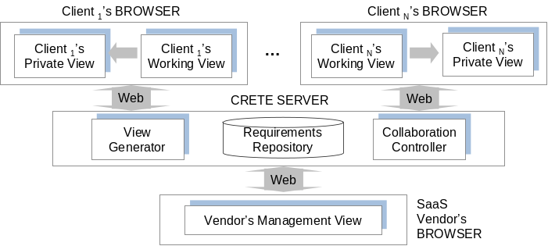
Fig. 1. CRETE Usage Scenario
In this typical usage scenario, clients log on to CRETE server with browser individually. Physically, a client might be a single person or an enterprise consisting of multiple persons. To make the scenario focus on illustrating how clients collaboratively present requirements, we assume there is a representative person from each enterprise client who can present requirements on behalf of all stakeholders from this client. So, we won’t further differentiate roles within an enterprise client and the collaboration among the roles within a client will be excluded from this usage scenario. Similarly, we regard SaaS vendor logging on the CRETE server as a single person for reasonable simplification.
After logging on to the CRETE server, a client reviews existing requirements on the to-be developed SaaS application in his working view. For the purpose of privacy protection, the client will see the content of existing requirements but won’t know exactly who else ever presented the requirements. We suggest a client reviewing and voting on existing requirements before presenting new requirements. A client can reuse some of those existing requirements by voting “yes” on relevant elements. Or, the client can vote “no” on relevant elements if it doesn’t align with his requirements. With this approach, the commonality and variability among multiple clients’ requirements are identified gradually and implicitly, which significantly saves SaaS vendor’s effort. Besides reviewing and voting on existing requirements, a client can also input new requirements in the format of feature model ‎[12]. The client might input a feature that describes a valuable software characteristic, input refinement and/or constraint relationships among features. In the private view, a client can review all requirements he regarded as necessary for the to-be developed SaaS application. The requirements might either be reused from others or be presented by himself. He also needs to resolve the conflict existing in the private view promptly to make it always be consistent.
In this scenario, A SaaS vendor can use his management view to propose some initial requirements for a to-be developed application. With these initial requirements, clients can vote on them and be inspired to propose new requirements. Meanwhile, the SaaS vendor can review all requirements about the application. In this view, he is presented with the creator, the supports, and the dissenters of each requirement. He can understand which requirements are required by all or most of the clients while which requirements are required by a minority of clients. Also, he can attach the requirement relationships on the management view from application development perspective. Finally, the vendor can make requirement prioritization based on the information in his management view.

2.2 CRETE Requirement Repository
CRETE requirement repository stores not only all requirements presented by every clients, but also collaboration-related information (for example, the creation or voting actions a client performs on a requirement). As mentioned in 2.1, we leverage feature model to represent requirements. The collaboration related information is attached based on the feature model. Error: Reference source not found shows the major structure of CRETE requirement repository.
Data in the repository that represents a SaaS application’s requirements includes “feature”, “refinement”, and “constraint”.Also, the creator of those requirement elements is recorded in the repository. A feature denotes a software characteristic having sufficient client value. We consider two kinds of inter-feature relationships. The refinement relationships organize features with different levels of abstraction or granularities into a hierarchical structure. A refinement relationship between two features represents that the child feature is refinement of the parent feature. If a feature is selected, its mandatory children features must be selected as well, while its optional children can either be removed or selected. The constraint relationships describe dependencies between features. For the sake of simplicity, we consider only two basic kinds of constraints in this paper: requires and excludes. Given two features A and B, A requires B means that if A is selected, B must be selected as well. A excludes B means that at most one of them can be selected at the same time. These two kinds of constraints are created by SaaS vendor when proposing the initial requirements for the application. While a client is picking some elements from the initial requirements by voting “yes”, above constraints will be checked to make sure the client’s selection is complete and consistent. For example, suppose SaaS vendor creates a constraint “feature A requires feature B”, if a client votes “yes” to A, he should also vote “yes” to feature B. Similarly, suppose SaaS vendor creates a constraint “feature A excludes feature B”, if a client votes “yes” to A, he should not also vote “yes” to feature B.
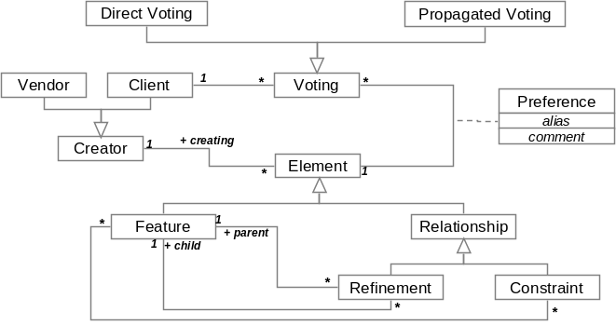
Fig. 2. Major Structure of CRETE Requirement Repository
Data in the repository that represents the collaborative requirement modeling information includes “direct voting”, “propagated voting” and “preference”. A client can apply two basic actions to a requirement element (feature or relationship). That is, a client can either create a new element or directly vote on an existing one. The voting types include: “yes”, “no”. If a client votes “yes” on an existing element, it implies that he wish to include this element in his requirement model. We allow the client to set his preference on this element, include the element’s alias, comment to this element’s original name or description, etc.. If a client votes “no” on an existing element, it implies that he wish to exclude this element from his requirement model. Besides, propagated voting can be automatically applied on an element as a consequence of a directly voting initiated by a client. For example, if there is a direct voting “yes” applied to a refinement relationship, there will be a corresponding propagated voting “yes” to the two features involved in this relationship.

2.3 Client’s Views
Each client works with two views during the process of proposing requirements. One is client’s working view and the other is client’s private view.
Client’s working view (CWV) is a client’s main workspace to build requirement model for a SaaS application. In the CWV, a client can create requirements and echo existing requirements presented by the SaaS vendor or other clients. The entities in the CWV are extracted from the CRETE requirement repository according to the view generation rule1, which includes all “feature” and “refinement” elements that the clients hasn’t vote “no”. According to the definition of feature model, constraint like “requires” or “excludes” is valid at product line level instead of application level. So it’s appropriate to have SaaS vendor instead of individual SaaS client review and operate on “constraint” elements. In CWV, elements with type of “constraint” will not be presented for clients to voting. They will only be used at the backend to check the validity of a client’s voting. If an element is voted “no” by all clients, it will be excluded from VMV.
View generation rule1:
CWV (Application s, Client c) =
{Element e | ( e.Application == s ) ∧
( e.Type != “constraint” ) ∧
(! ∃v∈Voting, v.Type==“no”∧ v.Client==c ∧ v.Element == e) }
Client’s private view (CPV) is to represent a client’s proprietary perspective on the requirements on the SaaS application. The entities in the CPV are extracted from the CRETE requirement repository according to the view generation rule2, which includes all “feature” and “refinement” elements that the client has voted “yes” (For an element created by the client, CRETE will automatically add a “yes” voting to the element for this client).
View generation rule2:
CPV (Application s, Client c) =
{Element e | ( e.Application == s ) ∧
( ∃a ∈ Creating, a.Client == c ∧ a.Element == e ) ∧
(∃a ∈ Voting, a.Type == “yes” ∧ a.Client == c ∧ a.Element == e ) }

2.4 SaaS Vendor’s Views
The SaaS vendor works with his management view (VMV) during the process of requirement elicitation. In VMV, the vendor can create some initial requirements for a to-be developed application, with which clients can vote on them or be inspired to propose new requirement. Also, the vendor can review all the requirements about an application. The entities in the VMV are extracted from the CRETE requirement repository according to the view generation rule3. If an element is voted “no” by all clients, it will be excluded from VMV.
View generation rule3:
VMV (Application s) =
{Element e | ( e.Application == s )
(! ∃v∈Voting, v.Type==“yes”∧ v.Element == e) }
Besides the entities, the vendor is presented with the creator, the supports, and the dissenters of each entity. Then, he can understand which requirements are required by which clients. Also, he can attach the requirement relationships on the management view from application development perspective. For example, the “excludes” constraint can be added between two features to indicate their conflict due to development considerations. With the information in VMV, the vendor can make requirement prioritization finally.

2.5 Requirements Construction Operations
CRETE provides two basic operations for a client to construct his requirements. One is creating and the other is voting.
Creating is to allow a client adding a new requirement element from his perspective, which implies a yes vote to this created requirement element. Table I lists the restrictions on creation. The restrictions fall into two categories. The restrictions in the first category are to make sure that the new created feature element should not duplicate existing features in the CRETE requirement repository. Name is used as the unique identity for a feature element, so two elements with the same name are forbidden. The restrictions in the second category are to make sure that the created requirement element should be consistent with all existing requirement elements created or voted by same client.
Table 1. Restrictions on creation
Element | Restriction
Feature | The feature does not exist in CRETE requirement repository.
Refinement  (X refines Y) | X and Y are existing features in current client’s private view and no “X refines Y” existed.
Constraint  (X requires Y) | X and Y are existing features in current client’s private view and no “X requires Y” existed.
Constraint  (X excludes Y) | X and Y are existing features in current client’s private view and no “X excludes Y” or “Y excludes X” existed.
Voting is to allow a client expressing their viewpoints on requirements presented by other clients. He gives a yes voting to a requirement element means that he feels it is also his requirement. Meanwhile, he can attach his preference about this element to the voting, including the alias, the description of the element, and the optionality of the element if it is a feature. He gives a no voting to a requirement element means that he feels it is not his requirement. Then it will be excluded from his requirement model.
Due to the semantic relationship among requirement elements, while a client represents positive or negative opinion on one requirement element, it may imply that he has accordingly positive or negative opinion on other relevant requirement elements. One straightforward approach is to let the client give voting to all involved requirement elements. However, to save the client’s effort, CRETE will automatically generate voting to some requirement elements according to his direct voting on other related requirement elements. For example, if a client agrees on feature A, feature B and the refinement relationship between feature A and B presented in his working view, there is no need for this client to give yes voting to all the three elements. Instead, he only needs to give yes voting on the refinement relationship between feature A and B, yes voting will be automatically propagated to feature A and feature B. Table II lists the propagation rules that CRETE follows to automatically propagate voting:
Table 2. Voting propagation rules
ID | Rules
PR-1 | Vote yes on Relationship r -> Vote yes on Feature f, f is involved in r
PR-2 | Vote no on Feature f -> Vote no on Relationship r, f is involved in r
3. Collaborative Requirement Construction Process
3.1 Process Overview
There are two kinds of activities during the collaborative requirement construction, namely client activities that performed by clients and system activities that performed automatically by the system according to predefined rules.
Table 3. Requirement construction activities
Activity | Description
Client Activities
Submit Operation | Submit creating and voting operations.
Resolve Conflicts | Resolve conflicts in the working view.
System Activities
Propagate Votes | Propagate votes after operations are submitted.
Coordinate Operations | Coordinate the operations submitted by clients, then store the actor and content of each valid operation.
Update Views | Update private views and working views for clients and update global view for SaaS vendor.
Error: Reference source not found shows the process of collaborative construction of a SaaS application’s requirements. A client goes through the following steps iteratively:
Update Views: When a client starts to work, his private view and working view are automatically generated for them. Whenever a client has successfully submitted operations, his private view and working view are updated and all other clients’ working views are updated as well. Particularly, update of the working view includes a detection of conflicts.
Resolve Conflicts: When his working view is updated, a client should first focus on the conflicts detected in his working views and resolve them via the creating and/or voting operations. Conflict resolving will be elaborated in Section 3.2.
Submitting Operations: In addition to conflict resolution, a client constructs his requirements by submitting operations. He creates a requirement totally new by submitting creating operation and adds a requirement already presented by others by submitting yes voting operation. To remove those requirements already presented by others from his working view, a client should submit no voting.
Propagate Votes: Propagated votes are computed according to rule PR-1 and PR-2 after an operation was submitted.
Coordinate Operations: In the context of collaborative work, changes submitted by multiple clients need to be coordinated. After the coordination, if the original changes are still valid, they are stored in the CRETE requirement repository and in turn, cause the update of views of all clients; otherwise the changes are neglected and its submitter will be informed. Operation coordination will be elaborated in Section 3.3.
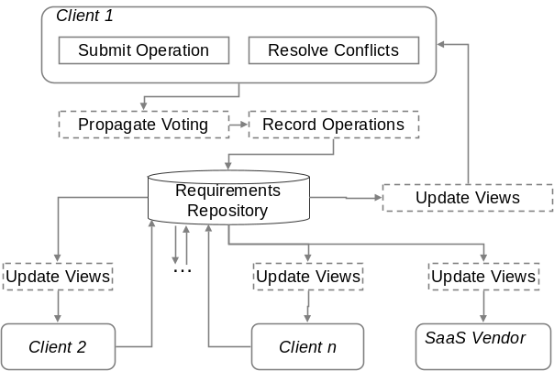
Fig. 3. Requirement Construction Process
3.2 Conflict Resolution
As the requirement elements presented in a client’s working view are from multiple clients, it’s common there are conflicts. Meanwhile, a client’s operations also bring conflicts to his working view. To generate a consistent private requirement model, a client should start from resolving the conflict via voting. Error: Reference source not found illustrates the potential conflicts in a client’s working view.
Non-positioned Feature (NPF): the client has denied all existing positions of a feature without giving a new one. (A feature must either be positioned as a root feature, or as a child of another feature.)
Conflicting Refinements (CR): multiple refinements existing in a working view are considered conflicting if they involve the same feature as the child but different features as the parent.
Conflicting Constraints (CC): multiple constraints existing in a working view are considered conflicting if there are two involved features A and B, where both A excludes B and A requires B can be deduced from these constraints.
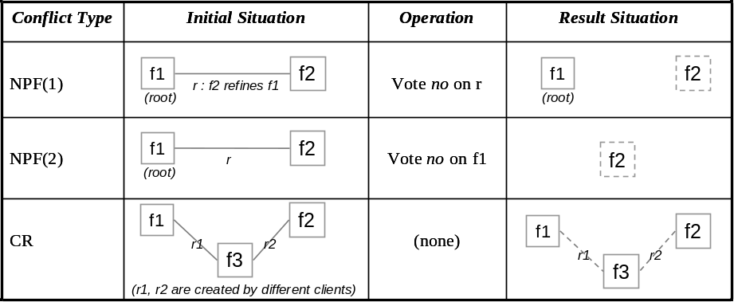
Fig. 4. Conflicts to be resolved
For a non-positioned feature, a client should create a refinement involving it as a child, or make it a root feature explicitly, or reconsider existing refinements. For conflicting refinements, a client should vote on these refinements to accept exactly one of them, or even denies all and create a new one. For conflicting constraints, a client should vote no on some of them until the conflict has resolved, or even denies all.
The conflicts in a working view actually define the minimal amount of work that a client must do to obtain a usable feature model that conforms to traditional feature models. For example, a newly joined client only needs to resolve conflicting refinements and conflicting constraints to transform his working view into a consistent requirement model specific to him. In addition, there is a bonus for him: aliases and descriptions of features contributed by different clients can help him deepen the understanding of the requirement he wants to include in his requirement model.
3.3 Operation Coordination
As different clients might work on the same requirements set while submitting operations, it is possible that their operations need to be coordinated. The need for coordination is rooted in the working view update delay problem: updates in the requirement repository caused by one client’s operation cannot immediately be visible to others. According to the operation types (creating or voting) that cause the repository updates, there are three possible situations to be coordinated, as illustrated in .
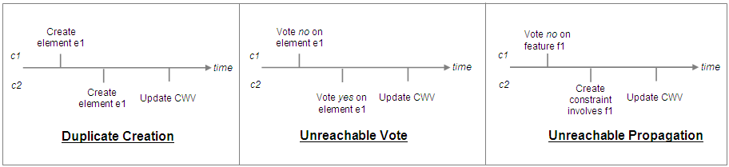
Fig. 5. Situations to be coordinated
Duplicate creation happens when a client (c2) creates an element e1 before a previous creation of the same element has became visible (i.e. update c2’s working view) to him. Therefore the creation of the same element happens twice.
Unreachable vote is a vote on a nonexistent element. As shown in , if c1’s no vote on element e1 leads to the deletion of e1, and if c2 submits a yes vote on e1 before the deletion becomes visible to him, then c2’s yes vote is an unreachable vote.
Unreachable propagation is similar to unreachable votes. In , if c1’s no vote on feature f1 leads to the deletion of f1, and if c2 creates a constraint involving f1 before the deletion becomes visible to him, then the propagation of yes vote on f1 (according to the rule PR-1) is unreachable.
Coordination of these situations follows a serialized update strategy, that is, all update applies to the elements in the same order of their submission. Furthermore, if the update being applied is no longer valid, it fails and takes no effect, and its submitter will be informed the failure. For duplicate creations, the first creating operation adds a new element to the repository, and the latter is converted to a yes vote. In , c1 will create the element e1, and c2 will be prompted to give a yes vote on e1. For unreachable votes, they are no longer valid on a nonexistent element and are neglected. In , the element e1 will be deleted, and c2 will be notified that his yes voting on e1 is invalid. For unreachable propagations, they are neglected together with the operations which cause the propagations. In , the feature f1 will be deleted, and c2 will be notified that his operation for creating constraint that involves f1 is invalid.
3.4 Guidelines for Clients
In this sub-section, we propose a set of guidelines that help clients effectively utilize the operations and views to improve the collaboration.
Perform conflict resolution as a start. As we discussed before, conflicts provide a starting point for a client’s work, and should be the first priority for him.
Review existing requirements before presenting a new one. A client should always pay attention to reuse the requirement presented by others. By voting yes on the requirements he agrees on and voting no on the requirements he disagrees, the commonality and variance among multiple clients’ requirements can be identified automatically.
Use client’s private view to maintain it own consistent requirement model.
4. A Case Study
4.1 Introduction
(这里需要补充一个背景，即对在线招聘系统的简介，参考ChinaHR.com, 51job.com, zhaopin.com，系统的client是在系统上发布招聘信息的企业)
The case is conducted by four clients and a vendor. They request and review expected features of the system in our Collaborative Feature Requesting (CoFeatuRe) tool. CoFeatuRe implements all essential aspects of our approach, including automatic generation of client and vendor views, support of creating and voting on features, and organizing features with refinement relationships.
The five participants spend about two hours working simultaneously in the first day, and spend another a couple of hours working freely (at any time they like, and often at different time) in the next two days. In the end, the clients confirm their requirements in their private views, and the vendor gets the requested features for the system in his management view.
4.2 Results
There are totally 113 features proposed for the system, including 30 variant features. The clients have created all of these features, while the vendor’s work has focused on finding ambiguity and vagueness in the features and adjusting refinement relationships among the features. Some interesting observations have emerged from this case study.
One observation is that the efficiency of requirements elicitation (i.e. feature requesting) is greatly improved. The improvement is largely attributed to the parallelism in the construction of the feature model. First, the participants tend to focus on a certain part of the feature model at a time, and because our CoFeatuRe tool shows everyone’s editing location in the feature model, the participants always choose a different part from others, which leads to parallel creation and review of features in different parts of the feature model. Besides, it may be surprisingly that adjusting the refinement relationships among a group of features does not disturb the participants who are working on the corresponding features. For example, three different parent features are linked to a feature Browse Company Info at some time (i.e. three conflicting refinements), and when two participants are discussing and resolving these conflicting refinements, another participant continues his work on writing description and creating child features for the feature without any problem. Therefore, creation and review of features and refinements are usually parallel as well.
In addition, the efficiency is improved because participants are often inspired by others’ work. All participants have said that “by looking at what is being created by the others, I can always think of a related feature immediately.” For example, just a few seconds after a client proposing Browse Company Info, two features – Search Company and Publish Company Info – are created by another client. Furthermore, some participants have said that “although I have to understand others’ work, it is a lot easier to review an existing element than to think of and create a new one, therefore my efficiency is improved.” Table 4 shows the proposition of feature creation and reuse in each client’s private view, which is another evidence for the improvement of efficiency of our requirements elicitation.
Table 4. Features in each client’s private view (PV)
Client | Total number of features in PV | Number of features in PV that are created by the client | Number of features in PV that are created by others (voted YES by the client)
Client 1 | 91 | 21 (23.1%) | 70 (76.9%)
Client 2 | 87 | 37 (42.5%) | 50 (57.5%)
Client 3 | 94 | 34 (36.2%) | 60 (63.8%)
Client 4 | 104 | 21 (20.2%) | 83 (79.8%)

Another observation is that the result of elicitation matches the characteristic of SaaS applications very well, i.e. many variants in a common structure. The “many variants” can be observed in the vendor’s management view (Table 5), which shows our approach is capable of capturing variant requirements among the clients. The “common structure” emerges by comparing the structure of each client’s private view. We have observed that at the end of elicitation, all conflicting refinement relationships are resolved by the participants, therefore all private views have the same hierarchical structure – the only difference is some of the leaf features.
Table 5. Common and variant features in the vendor’s management view
Total number of features | Number of common features (presented in all 4 private views) | Number of features presented in 3 private views | Number of features presented in 2 private views | Number of unique features (presented in only 1 private view)
113 | 83 (73.5%) | 24 (21.2%) | 5 (4.4%) | 1 (0.9%)

The results show that our approach, especially the use of feature models for expressing and organizing requirements, is suitable for requirements elicitation of SaaS applications, and the explicit support for collaboration between clients and vendors has very positive influence on the efficiency of elicitation.

5. Related Works
5.1 feature-oriented requirements modeling
Our work in this paper is partly inspired by the research of feature-oriented requirements modeling [7][8][13][14], which is an important technique to capture the commonality and variability of software requirements in software product lines. The basic idea of feature-oriented requirements modeling is to partition software requirements into a set of features and explicitly identify the constraints among features (such a modeling artifact is call a feature model), thereby to increase the customizability and improve the reusability of software requirements. One implicit assumption of feature-oriented requirements modeling is that there is an available set of domain experts who possess a comprehensive understanding of the current software product line and thus can discover all the important commonality and variability in the software requirements. However, this assumption is generally not hold in the SaaS circumstance, because of the rapid evolution nature of SaaS applications and the low possibility of getting a suitable set of domain experts for SaaS applications, and thus it is impractical to apply the feature-oriented requirements modeling technique to SaaS applications’ requirements elicitation directly.
One improvement of our work in this paper is that it releases the feature-oriented requirements modeling technique from the above assumption, by integrating it with explicit collaboration mechanism and encapsulating it as a web-based application, so that the larger number of geographic-distributed uses/clients can express and share their requirements with each others in a collaborative and asynchronous way, and the SaaS vendor can collect adequate commonality and variability of a SaaS application’s requirements. Furthermore, our work in this paper also enhances the traditional feature-oriented requirements modeling technique with an effective evolution mechanism, that is, users/clients can continuously express their updated requirements about a SaaS application and the SaaS vendor can always get the latest commonality and variability requirements of a large number of users/clients.
5.2 collaborative requirements engineering
Another important research area related to our work is the research on collaborative requirements engineering. The idea of collaborative requirements elicitation can be traced to the Inquiry Cycle Model (ICM) 1515[15] proposed by Potts et al. in 1994, in which, the requirements elicitation is carried out through the iteration of three activities: requirements documentation, discussion and evolution. In this method, the collaboration among stakeholders uses the traditional meeting-based synchronous mechanism, and no tool support is provided to facilitate or manage the collaboration among stakeholders. After that, a notable research work in this area is the CREWS 9[9] project, which collects a set of researchers from several European countries, and focuses on the problem of how to use the concept of scenario to facilitate the conduction of requirements engineering activities in collaborative ways. As the ICM method, the collaboration technique used in CREWS is still the traditional meeting-based mechanism. More recently, Decker et al. [16] proposed a Wiki-based approach to asynchronous collaborative requirements engineering. This approach utilize collaboration mechanisms provide by the Wiki platform to facilitate collaboration among stakeholders, and more particularly, to facilitate stakeholders’ collaborative editing on a set of use cases contained in a set of web pages. Comparing to the above research work, our work in this paper possess a distinguish characteristic. That is, all the above research work aims to get a suitable set of requirements for only a single customer or organization, and it is almost impossible for them to collect and analyze requirements containing variability requirements from different customers or organizations, while in our approach, a carefully designed collaboration mechanism is provided to collect requirements from a large number of different customers and to reflect the commonality and variability of those collected requirements. Such a characteristic makes our approach and tool more suitable for SaaS applications’ requirements elicitation.
References
- blank
- L. Herbert, E. G. Brown, and S. Galvin, “Competing in the fast-growing SaaS market”, Forrester Report, No. 0,5110,44254,00, 2008.
- E. TenWolde, “Worldwide software on demand 2007-2011 forecast: A preliminary look at delivery model performance”, IDC Report, No. 206240, 2007.
- Ma, D, The Business Model of "Software-As-A-Service”. In 2007 IEEE International Conference on Services Computing (SCC 2007), pages: 701–702, July 2007.
- Ralph Mietzner, Andreas Metzger, Frank Leymann, Klaus Pohl, “Variability modeling to support customization and deployment of multi-tenant-aware Software as a Service applications”, in Proceedings of the 2009 ICSE Workshop on Principles of Engineering Service Oriented Systems, pages: 18-25.
- Sun, W., Zhang, X., Guo, C., Sun, P., and Su, H. “Software as a Service: Configuration and Customization Perspectives”. SERVICES-2. IEEE, 2008, pages: 18–25.
- Kyo C. Kang, Sajoong Kim, Jaejoon Lee, Kijoo Kim, Euiseob Shin, and Moonhang Huh, “FORM: A Feature-Oriented Reuse Method with Domain-Speciﬁc Architecture”, Annals of Software Engineering, vol. 5, pp. 143-168, Sept. 1998.
- Hong Mei, Wei Zhang, and Fang Gu, “A Feature Oriented Approach to Modeling and Reusing Requirements of Software Product Lines”, 27th International Computer Software and Applications Conference (COMPSAC’03), Dallas, TX, USA, pp.250-256, 2003.
- CREWS Homepage. http://sunsite.informati k.rwth-aachen.de/CREWS/.
- to be added
- to be added
- W. Zhang, H. Mei, H. Zhao, “A feature-oriented approach to modeling requirements dependencies,” in Proc. of the 13th IEEE Intl. Conf. on Requirments Engineering (RE 05), 2005, pp. 273–282.
- P. Clements, and L. Northrop, “Software Product Lines: Practices and Patterns”, Addison-Wesley Professional, 2001.
- Kyo C. Kang, Sholom G. Cohen, James A. Hess, William E. Novak, and A. Spencer Peterson, Feature-Oriented Domain Analysis Feasibility Study, Technical Report(SEI-90-TR-21), Software Engineering Institute, Carnegie Mellon University, Nov. 1990.
- C. Potts, K. Takahashi, A.I. Anton. Inquiry-Based Requirements Analysis. IEEE Software, 1994, 11(2):21-32.
- B. Decker, E. Ras, J. Rech, P. Jaubert, and M. Rieth. Wiki-Based Stakeholder Participation in Requirements Engineering. IEEE Software, 2007, 24(2):28-35.

